Quick Overview:

The authorization is in HHAX or not, some cases missing authorization or imported failure. Also need the file name to see status.

The reason why schedule in SAM, but not in HHAX, need to investigate, or schedules status not updated.

Payor is setup using HHAX export or not in SAM.

From Eric’s request:

I couldn’t find tickets related to Completed Visits, Billing, and Caregiver records.

Faye sent in the attached email advising that for the below client, their schedules did not make it to HHAX even through it was processed and is closed in SAM.

Client Name: Iolanda Sirtori

adID: 9166598

Member ID: 000019021

DOS: 2/15/2018

Sched ID: 37309270

**ASK:**Please advise why this schedule did not transfer and update in HHAX?

**NOTES BY Tier 3 by Eric D.**

**11/13/2018.**

The employee "CALEB, GENOUIA" had a schedule overlap on this date/time. The schedule with id "37309270" was rejected by HHAX with the following error "Overlapping shifts are not allow”.

Please turn on the HHAX to SAM client visit feed on the following DB to enable us to do final testing.

Partners in Care - Visit did not transfer over to HHAx. A schedule is existed in SAM, but not in HHAX

Patient Dover, l has an authorization in HHA Exchange from 9/19/18 to 2/28/19, however this authorization is not in HCplus.  Please advise.

**Response:** The authorization cannot be imported because the patient has not been imported as yet.

The patient cannot be imported because there is no county information. I am guessing that the Middleware cannot determine the county because the process cannot determine GPS data from the patient’s address  “415 NATIONAL OTH APT# 3K “ (but, I admit, I do not know what data is used by the Middleware to determine the patient’s county).

You could send the ticket to Khang Le (Middleware) for an explanation, and then back to the customer for them to act on his explanation.

If you wish I could manually enter “Nassau” in the patient’s demographics record and re-process the patient, and then the authorization. Note, that subsequent updates of the patient record will fail if the address is not corrected.

This is not something I should be doing, but I do have to complete at least one more good deed before midnight tonight, otherwise the great and frightful Krampus will return and confiscate all of my antidepressants.

And who will be happy then?

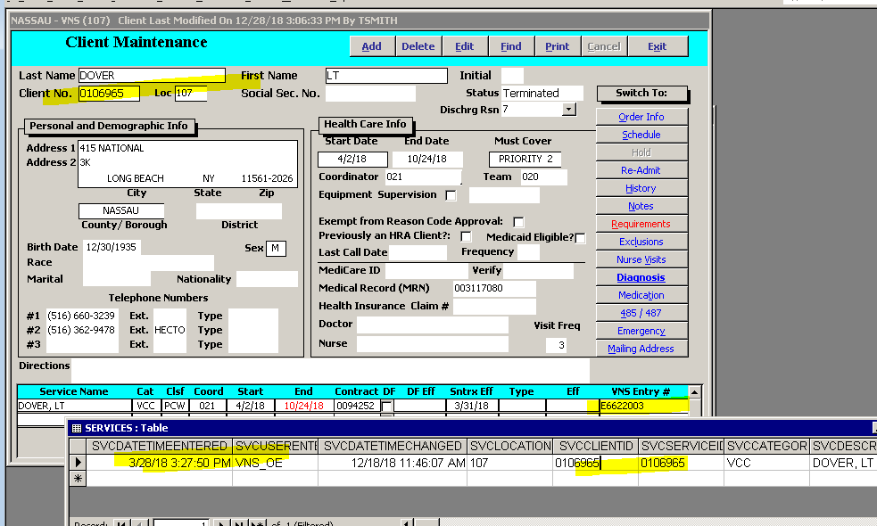

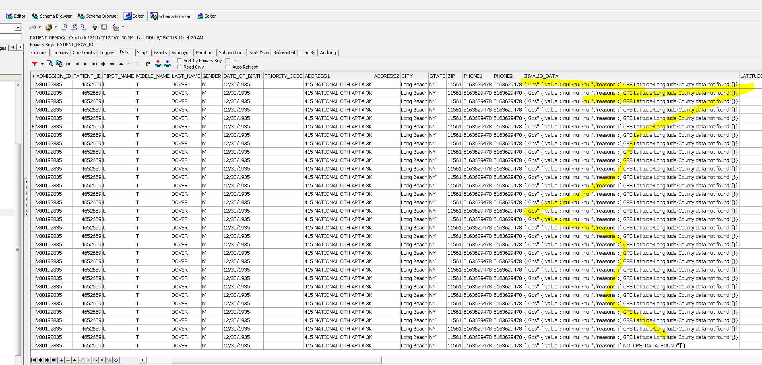

Patient Arthur Davis authorization was accepted in HHA Exchange on 12/5/18 at 11:59 am, however the authorization is not in Hcplus.  Please investigate.

The authorization has been exported in file name LTDOUT_337_18121_PatAuth_20181208021018.csv. Please confirm whether a has updated with this data.

**RESPONSE:**

The following authorizations for member with ADMISSION_ID = 'V80193818' have failed...Out of the four unique authorizations, only one of the four authorizations has processed successfully. The other three authorizations are showing a status of '2' in the HHAX_Integration system. See below for a list of the authorizations currently in the Sandata HHAX staging database  
  
Authorization_ID value(s) that are failing with a TRANSACTION_STATUS_ID = 2 (*2 = Processed with Errors*)  
7309649  
7309650  
7319421  
  
Authorization_ID value(s) that have processed succefully with TRANSACTION_STATUS_ID = 1 (*1=Successfully Processed*)  
7559700  
  
[Ian Bacchus](https://sandata.zendesk.com/agent/users/366033113527)​, can you review this ticket and provide additional information regarding the following errors found for these failed transactions?   
  
The transactions are failing with the following HCO_ERR_DESC values of: 

* Exception during Dynamic SQL execution
* Failed to process transaction.

The transactions are failing with the following ORA_ERR_DESC values of:

* ORA-04061: existing state of  has been invalidated
* ORA-04061: existing state of package body "PEOPLECARENY.PKG_HHAX_CLI" has been invalidated
* ORA-04065: not executed, altered or dropped package body "PEOPLECARENY.PKG_HHAX_CLI"
* ORA-06508: PL/SQL: could not find program unit being called
* User-Defined Exception

In every failed transactions the ERR_SOURCE value is the same. The value captured is "hhaxchange_stage1.PKG_TRANS.ProcessTransactions"

Attached is a list of clients that have missing authorizations within the last 30 days.

Can you please create a ticket to have these processed form the most recent full file received from HHAx?

|  |  |  |  |  |
| --- | --- | --- | --- | --- |
| Last Name | First Name | Auth Number | Date Auth was sent from HHAx | Admission ID |
| Fung | Lan | 4249 | 12/4/2018 | 67288 |
| Tsoi | Sau | 4138 | 12/3/2018 | 65865 |
| Tsoi | Sau | 4139 | 12/10/2018 | 65856 |
| Kwan | So | 4535 | 12/12/2018 | 72697 |
| Fee Chan | Ning | BB1260917 | 12/3/2018 | V80027558 |
| Fee Chan | Ning | 421392666 | 12/13/2018 | V80027559 |
| Hom | Susan | 4163 | 12/3/2018 | 66601 |
| Gao | Rong | DB1381267 | 12/3/2018 | V70014824 |
| Wong | Becky | 3707 | 12/21/2018 | 63721 |
| Wong | Becky | 3709 | 12/21/2018 | 63721 |
| Liu | Huiqin | 4318 | 12/5/2018 | 63254 |
| Song | Jung | 4057 | 12/13/2018 | 64998 |
| Kwan | So | 4534 | 12/11/2018 | 72697 |
| Eng | Ngook Hai | 10003796 | 12/17/2018 | 45780 |

Good Afternoon  
Sandata- Please send the file for patient Joan Gilroy, member services started yesterday 12/19/18  
HHAX- please assist in this request, patient Admission ID is 74481  
Thank you

**Sally Enriquez- Lewis**| Intake OPS Manager

105 Court Street, 2nd Floor  
Brooklyn, NY 11201  
Office: 718.875.8900 ext. 18203  
Fax:        718.875.8906  
Email:  [Senriquez@accentcare.com](mailto:Senriquez@accentcare.com)

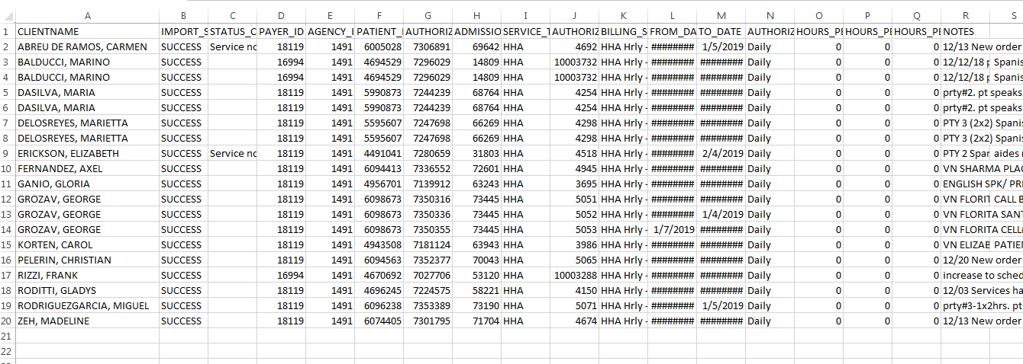

Kindly advise why Travel time Task code 85 is not translating as a Missed Visit in HHAX along with travel time Request.

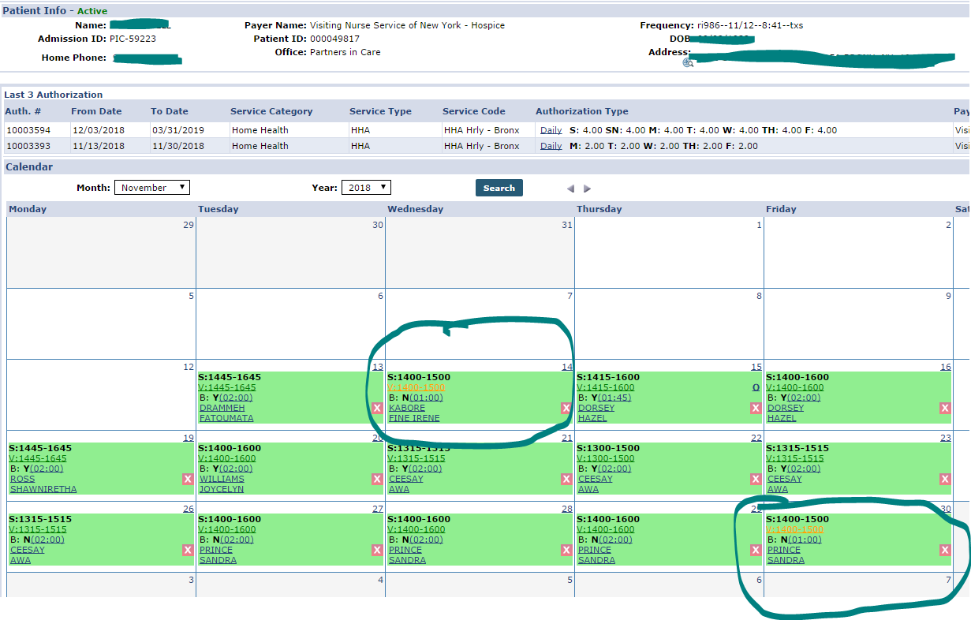

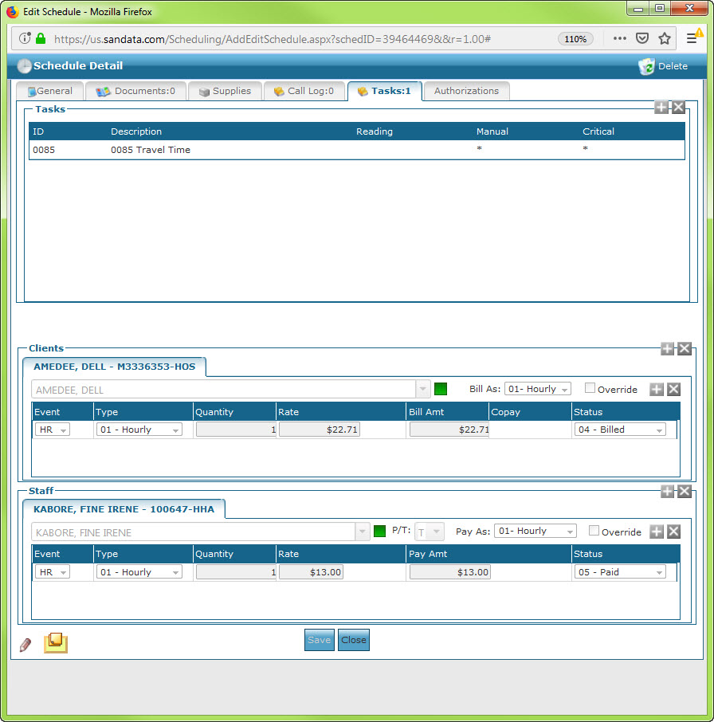

**Response:**

We dug deeper into this and it appears the visit in question did not meet the required criteria for sending a missed visit back to HHAX.  
  
Just adding a Task Code of 85 will not trigger the missed visit.    
  
The triggers are:  
 - OMIG Reason codes of either OM07, OM15 or OM21  
 - Visit Edit Reason Code   
 - Event Cancel   
  
The scripting has no criteria for the Task Code 85 which is why I asked whether this has worked for them in the past.  What we did notice is that for visits that had the Task Code 85 and did get flagged for a missed visit had the visit status (via the historian) set to Cancelled at one point and the changed back to Pending before having it be Confirmed.  This sent the missed visit over to HHAX which may have made the agency think that the Task Code 85 triggered it.

we are finding there are a number of visits processed in SAM never making it over to HHAX

**ASK: please review these visits to see if they were ever sent over to HHAX.**

**Response:** Please see the response below from HHAX for me finding out from you the file Export name and whether it was exported. In this case can you confirm whether you have the export file was done and the name .

There are some other clients for the same period with the same aide that is missing.